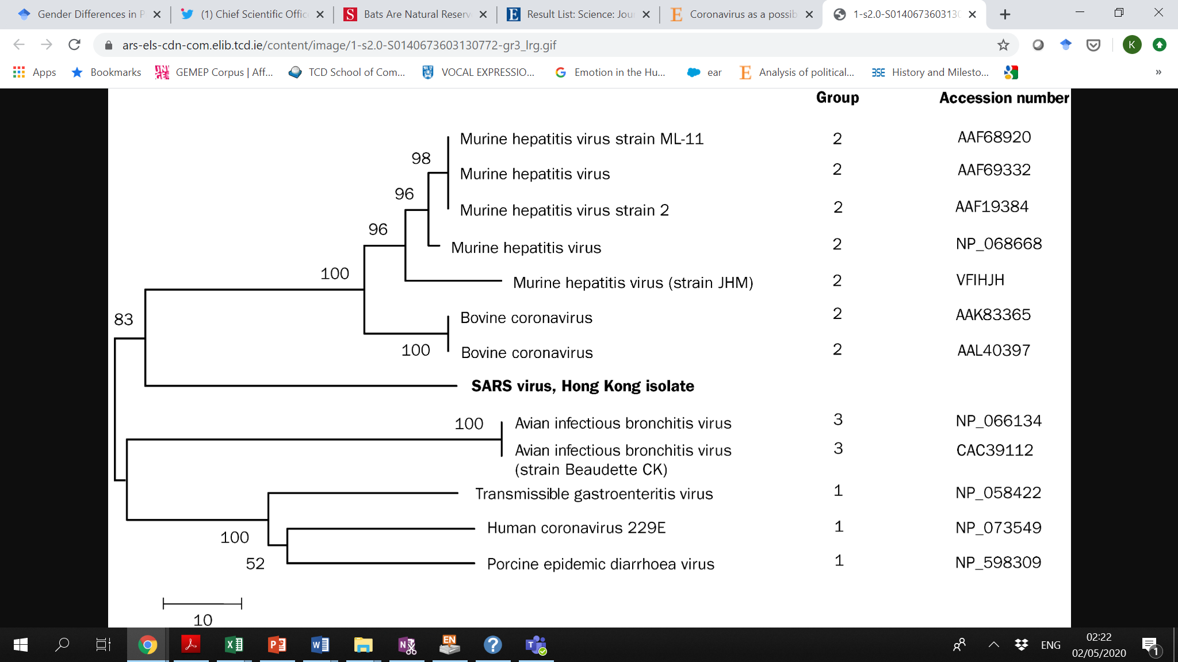

Figure 3. [Phylogenetic analysis](https://www-sciencedirect-com.elib.tcd.ie/topics/medicine-and-dentistry/phylogeny) of the partial [protein sequence](https://www-sciencedirect-com.elib.tcd.ie/topics/medicine-and-dentistry/peptide-sequence) (215 aminoacids) of the coronavirus (SARS)